**Mini Project Report**



Submitted to

**S.D.M COLLEGE (AUTONOMOUS),**

**Ujire – 574 240**

**MINI PROJECT ON SCHOOL MANEGMENT**

By

**Shrungadithya**

**Roll No: 201329**

Under the guidance of

**Mr. Sammed Jain**

Assistant Professor

**SRI DHARMASTHALA MANJUNATHESHWARA COLLEGE**

**(AUTONOMOUS),**

**Ujire – 574240**



**DEPARTMENT OF BVOC**

**(SOFTWARE AND APPLICATION DEVELOPMENT)**

**Certificate for the approval of project report**

This is to certify that shrungadithya, 201329 of I BVoc has satisfactorily completed the project

“**Mini Project of school management"**

Software and Application Development Degree

Prescribed by the college during the academic year 2020 – 2021.

Mr. Shailesh Kumar Mr. Sammed Jain Prof. Satheeshchandhra S

**Head of the Department Project Guide Principal**

Examiners:

1.

2.

**DECLARATION**

I hereby declare that this project work entitled “**Mini Project of school manegment***”* has been prepared by me during the year 2019 – 20 under the guidance of **Mr**. **Sammed Jain**, Department of BVoc (Software and Application Development), SDM College in the partial fulfillment of BVoc degree prescribed by the college.

I also declare that this project is the outcome of my own effort, that it has not been submitted to any other university for the award of any degree.

**Shrungadithya**

**201329**

**ACKNOWLEDGEMENT**

I would like to thank our principal Prof. Satheeshchandhra S, for his support. We also thank Mr. Shailesh Kumar HOD, Department of BVoc, SDM College Ujire, for his valuable suggestions.

I would like to thank Mr. Sammed Jain, Department of BVoc, SDM College Ujire, for their help and for providing guidance in developing the project.

Shrungadithya

201329

**Index Page**

|  |  |  |
| --- | --- | --- |
| **SL.NO** | **Topic Name / Chapter Name** | **Page no** |
| **1.** | **Introduction** | **06** |
| **2.** | **Requirement Specification** | **08** |
| **3.** | **Implementation** | **10** |
| **4.** | **Result** | **11** |
| **7.** | **Source Code** | **16** |
| **6.** | **Conclusion and Scope of future work** | **29** |
| **7.** | **Bibliography** | **30** |

**Chapter 1**

**Introduction**

**A school manegment is an educational institution designed to provide learning spaces and learning environments for the teaching of students (or "pupils") under the direction of teachers. Most countries have systems of formal education, which is sometimes compulsory.[2] In these systems, students progress through a series of schools. The names for these schools vary by country (discussed in the Regional section below) but generally include primary school for young children and secondary school for teenagers who have completed primary education. An institution where higher education is taught, is commonly called a university college or university.**

**Etymology**

In addition to these core schools, students in a given country may also attend schools before and after primary (Elementary in the US) and secondary (Middle school in the US) education. Kindergarten or preschool provide some schooling to very young children (typically ages 3–5). University, vocational school, college or seminary may be available after secondary school. A school may be dedicated to one particular field, such as a school of economics or a school of dance. Alternative schools may provide nontraditional curriculum and methods.

**History**

The concept of grouping students together in a centralized location for learning has existed since Classical antiquity. Formal schools have existed at least since ancient Greece (see Academy), ancient Rome (see Education in Ancient Rome) ancient India (see Gurukul), and ancient China (see History of education in China). The Byzantine Empire had an established schooling system beginning at the primary level. According to Traditions and Encounters, the founding of the primary education system began in 425 AD and "... military personnel usually had at least a primary education ...". The sometimes efficient and often large government of the Empire meant that educated citizens were a must. Although Byzantium lost much of the grandeur of Roman culture and extravagance in the process of surviving, the Empire emphasized efficiency in its war manuals. The Byzantine education system continued until the empire's collapse in 1453 AD.[7]

In Western Europe a considerable number of cathedral schools were founded during the Early Middle Ages in order to teach future clergy and administrators, with the oldest still existing, and continuously operated, cathedral schools being The King's School, Canterbury (established 597 CE), King's School, Rochester (established 604 CE), St Peter's School, York (established 627 CE) and Thetford Grammar School (established 631 CE). Beginning in the 5th century CE monastic schools were also established throughout Western Europe, teaching both religious and secular subjects.

Islam was another culture that developed a school system in the modern sense of the word. Emphasis was put on knowledge, which required a systematic way of teaching and spreading knowledge, and purpose-built structures. At first, mosques combined both religious performance and learning activities, but by the 9th century, the madrassa was introduced, a school that was built independently from the mosque, such as al-Qarawiyyin, founded in 859 CE. They were also the first to make the Madrassa system a public domain under the control of the Caliph.

United Kingdom and Commonwealth of Nations

In the United Kingdom, the term school refers primarily to pre-university institutions, and these can, for the most part, be divided into pre-schools or nursery schools, primary schools (sometimes further divided into infant school and junior school), and secondary schools. Various types of secondary schools in England and Wales include grammar schools, comprehensives, secondary moderns, and city academies. In Scotland, while they may have different names, there is only one type of secondary school, although they may be funded either by the state or independently funded. School performance in Scotland is monitored by Her Majesty's Inspectorate of Education. Ofsted reports on performance in England and Estyn reports on performance in Wales.

In the United Kingdom, most schools are publicly funded and known as state schools or maintained schools in which tuition is provided for free. There are also private schools or independent schools that charge fees. Some of the most selective and expensive private schools are known as public schools, a usage that can be confusing to speakers of North American English. In North American usage, a public school is one that is publicly funded or run.

In much of the Commonwealth of Nations, including Australia, New Zealand, India, Pakistan, Bangladesh, Sri Lanka, South Africa, Kenya, and Tanzania, the term school refers primarily to pre-university institutions.

**India**

**A school building in Kannur, India**

**In ancient India, schools were in the form of Gurukuls. Gurukuls were traditional Hindu residential schools of learning; typically the teacher's house or a monastery. During the Mughal rule, Madrasahs were introduced in India to educate the children of Muslim parents. British records show that indigenous education was widespread in the 18th century, with a school for every temple, mosque or village in most regions of the country. The subjects taught included Reading, Writing, Arithmetic, Theology, Law, Astronomy, Metaphysics, Ethics, Medical Science and Religion.**

**Under the British rule in India, Christian missionaries from England, USA and other countries established missionary and boarding schools throughout the country. Later as these schools gained in popularity, more were started and some gained prestige. These schools marked the beginning of modern schooling in India and the syllabus and calendar they followed became the benchmark for schools in modern India. Today most of the schools follow the missionary school model in terms of tutoring, subject / syllabus, governance etc.with minor changes. Schools in India range from schools with large campuses with thousands of students and hefty fees to schools where children are taught under a tree with a small / no campus and are totally free of cost. There are various boards of schools in India, namely Central Board for Secondary Education (CBSE), Council for the Indian School Certificate Examinations (CISCE), Madrasa Boards of various states, Matriculation Boards of various states, State Boards of various boards, Anglo Indian Board, and so on. The typical syllabus today includes Language(s), Mathematics, Science – Physics, Chemistry, Biology, Geography, History, General Knowledge, Information Technology / Computer Science etc.. Extra curricular activities include physical education / sports and cultural activities like music, choreography, painting, theater / drama etc.**

**Security**

**To curtail violence, some schools have added CCTV surveillance cameras. This is especially common in schools with gang activity or violence.**

**The safety of staff and students is increasingly becoming an issue for school communities, an issue most schools are addressing through improved security. Some have also taken measures such as installing metal detectors or video surveillance. Others have even taken measures such as having the children swipe identification cards as they board the school bus. For some schools, these plans have included the use of door numbering to aid public safety response.[clarification needed]**

**Other security concerns faced by schools include bomb threats, gangs, and vandalism.[17] In recognition of these threats, the United Nations Sustainable Development Goal 4 advocates for upgrading education facilities to provide a safe, non-violent learning environment.[18]**

**Chapter 2**

**Requirement Specification**

Requirements specification is a specification of software requirements and hardware requirements required to do the project. Requirements analysis encompasses those tasks that go into determining the needs or conditions to meet for a new or altered product or project, taking account of the possibly conflicting requirements of the various stakeholders, analyzing, documenting, validating and managing software or system requirements.

**2.1 Hardware Requirements**

|  |  |  |
| --- | --- | --- |
| **Sl.No** | **Hardware / Equipment** | **Specification** |
| **1.** | **Processor** | **Intel i7 Core Processor** |
| **2.** | **RAM** | **6GB** |

**2.2 Software Requirements**

|  |  |  |
| --- | --- | --- |
| **Sl.No** | **Software** | **Specification** |
| **1.** | **Web Browser** | **Google Chrome** |
| **2.** | **Operating System** | **Windows 7** |
| **3.** | **Scripting** | **HTML, CSS, JavaScript** |

A web browser, or simply "browser," is an application used to access and view websites. Common web browsers include Microsoft Internet Explorer, Google Chrome, Mozilla Firefox, and Apple Safari. The primary function of a web browser is to render HTML, the code used to design or "markup" webpages. Each time a browser loads a web page, it processes the HTML, which may include text, links, and references to images and other items, such as cascading style sheets and JavaScript functions. The browser processes these items, then renders them in the browser window.

An operating system is a software which acts as an interface between the end user and computer hardware. Every computer must have at least one OS to run other programs. An application like Chrome, MS Word, Games, etc.,,, needs some environment in which it will run and perform its task. The OS helps user to communicate with the computer without knowing how to speak the computer's language. It is not possible for the user to use any computer or mobile device without having an operating system.

A script or scripting language is a computer language with a series of [commands](https://www.computerhope.com/jargon/c/command.htm) within a file that is capable of being executed without being [compiled](https://www.computerhope.com/jargon/c/compile.htm). Good examples of [server-side scripting](https://www.computerhope.com/jargon/s/server-side-scripting.htm) languages include [Perl](https://www.computerhope.com/jargon/p/perl.htm), [PHP](https://www.computerhope.com/jargon/p/php.htm), and [Python](https://www.computerhope.com/jargon/p/python.htm). In this project PHP is used for web application development. The best example of a client side scripting language is [JavaScript](https://www.computerhope.com/jargon/j/javascript.htm). A full list of scripting languages and other programming languages can be found through our [programming HYPERLINK "https://www.computerhope.com/jargon/p/programming-language.htm" language](https://www.computerhope.com/jargon/p/programming-language.htm) definition. In this project CSS, html, JavaScript are used for client side programing.

**Chapter 3**

**Implementation**

Implementation is a process of development of an application. Once the system design is completed then actual development of system will starts. The development of application using system design is called the implementation phase. In this phase, largest system is divided into small modules. For each module, algorithms are developed and each algorithm is coded using programming languages.

**Chapter 4**

**Results**

Results basically refer to any particular output that comes as a result of the completion of the activities that have been performed as part of the project or a particular project component. In this page there are top view, bottom view etc. Top view consists navigation part with five buttons Home,Login, Register,Gallery. In the center of the navigation part there is logo.In the navigation botton have maquee is there in that i mantion AKSHARA PU COLLEGE and slideshow of Image . In bottom view, you can see Akshara college address, principal in information, About us . To contact us, know about us, and also location

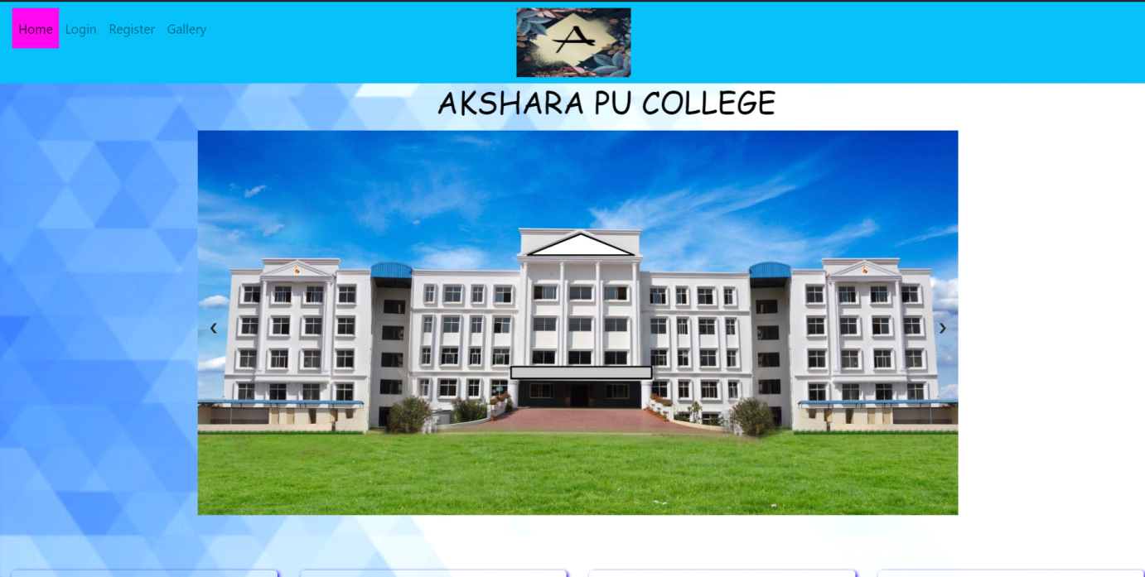

Figure 4.1: Login Page

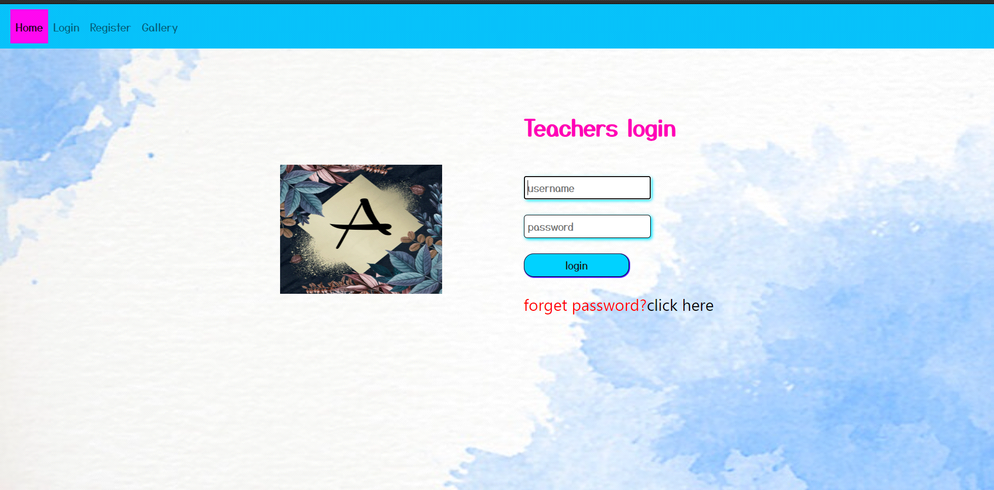

This page consist of navigation bar it consist of Home, Login, Register, Gallary. Middal of the page has Teacher login in that I use div tag display flex this used for college Logo and requred text diveded.username and passward is used for teachers login. And it has forget passward.

Figure 4.2: Manegment Login

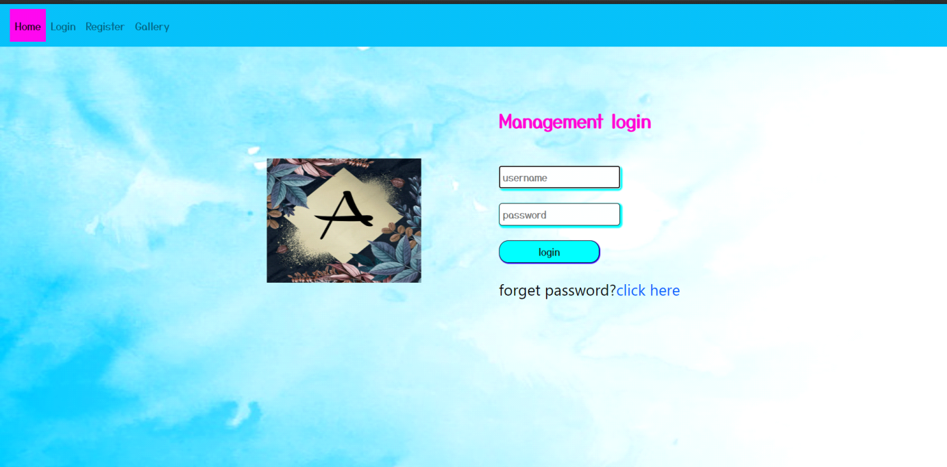

This page consist of navigation bar it consist of Home, Login, Register, Gallary. Middal of the page has Manegment login in that I use div tag display flex this used for college Logo and requred text diveded.username and passward is used for management login. And it has forget passward.

Figure 4.3: Register page

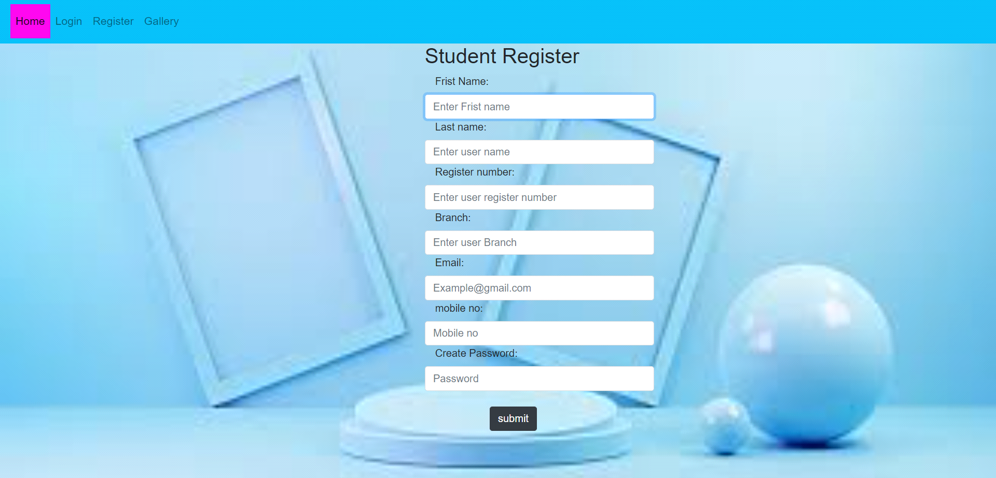

This page consists of student register. Here is the page to register of student. we have to give first name, last name, registration no etc..

Figure 4.4: Gallary page

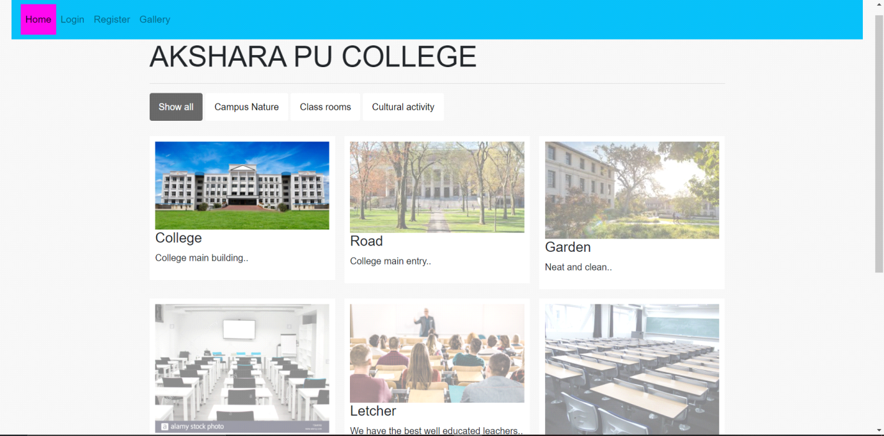

This page consist of navigation bar it consist of Home, Login, Register, Gallary. this page consist of college image, college campus, class rooms, cultural activity. And that information.

Figure 4.5: Forget passward

Once you click on you have to fill the sa

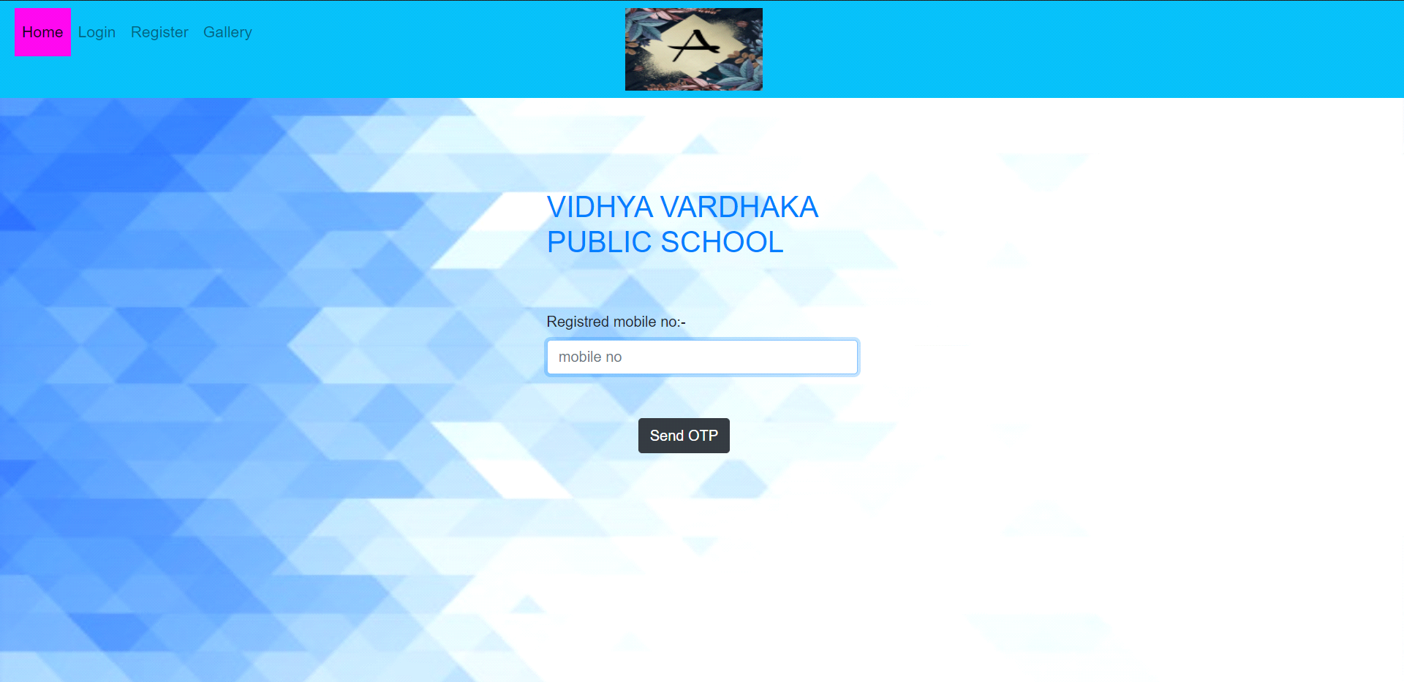

This page consist of navigation bar has Home, Login, Register, Gallary.and center of page has the college name and requiried mobile no.

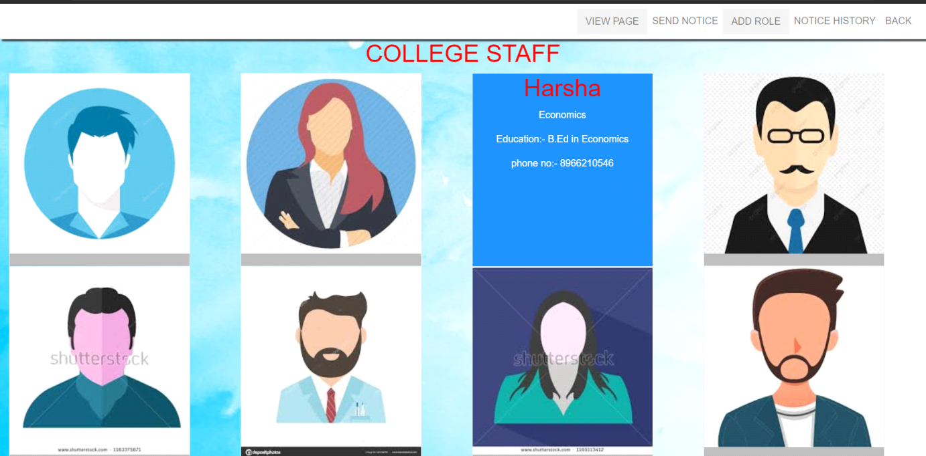

This page consist of navigation bar it has view page, send notice, add staff, notice history,back. It has view the staff.

Figure 4.6: Notice

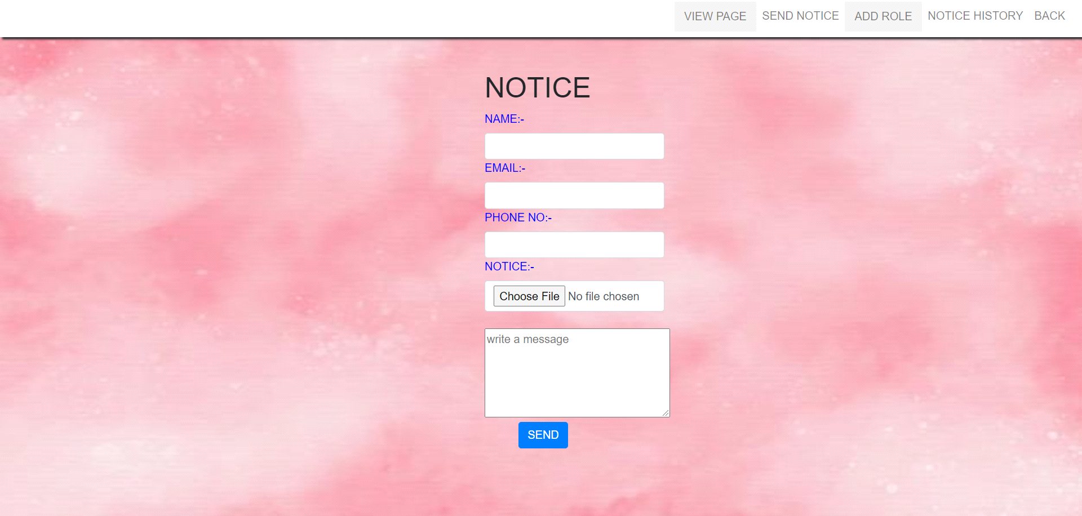

This page consist of navigation bar it has view page, send notice, add staff, notice history,back. this page is notice page. For send notice to the class.

Figure 4.7: Student ditails

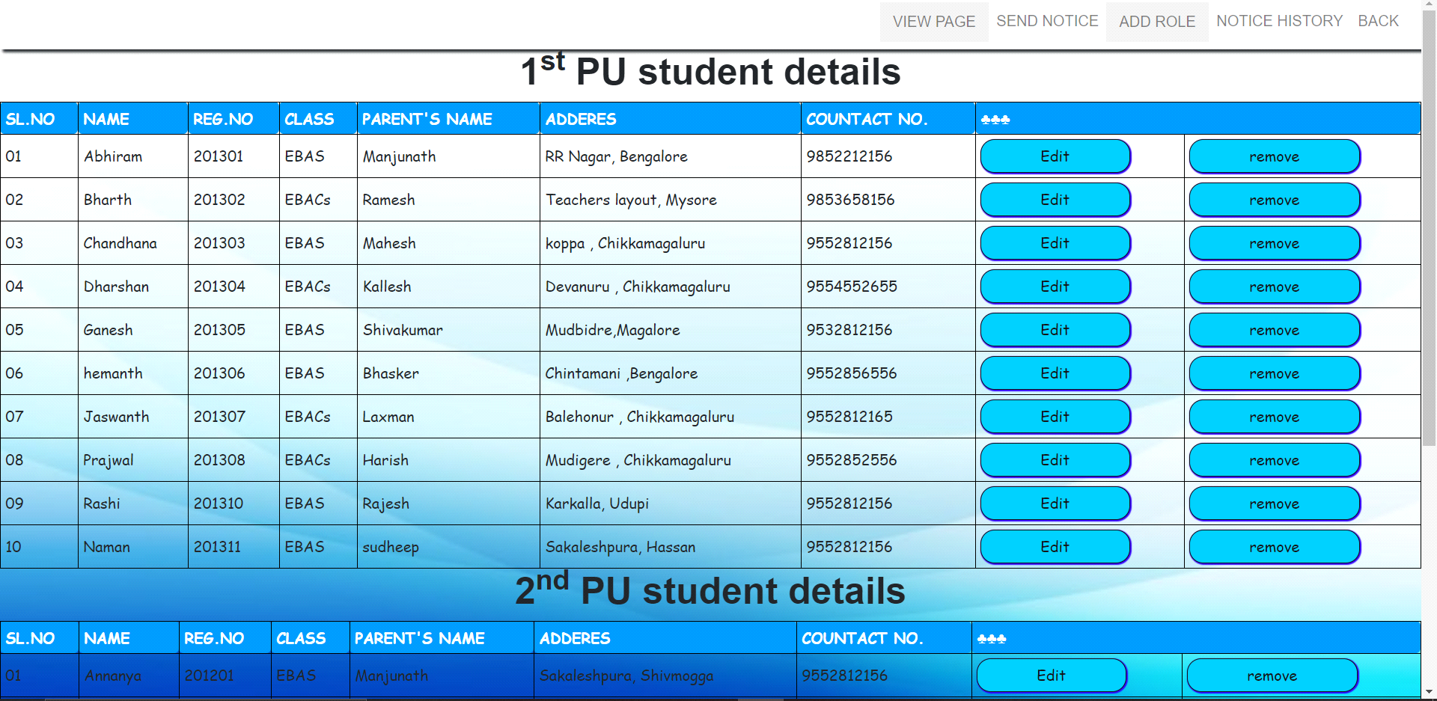

This page consist of navigation bar it has view page, send notice, add staff, notice history,back. this page is view the student notice.

Figure 4.8: More Places

**Chapter 5**

**Source Code**

**Home page**

<!DOCTYPE html>

<html lang="en">

<head>

<meta charset="UTF-8">

<meta name="viewport" content="width=device-width, initial-scale=1.0">

<title>School management</title>

<link rel="stylesheet" href="../css/bootstrap.min.css">

<!-- <link rel="stylesheet" href="https://use.fontawesome.com/releases/v5.7.0/css/all.css"/> -->

<link rel="stylesheet" href="../css/home.css">

</head>

<body>

<nav class="navbar navbar-expand-lg navbar-light bg-light my-cls">

<button class="navbar-toggler" data-target="#navbarToggler" type="button" data-toggle="collapse">

<span class="navbar-toggler-icon"></span>

</button>

<div class="collapse navbar-collapse " id="navbarToggler">

<ul class="navbar-nav mr-auto">

<li class="nav-item-active">

<a href="../index/home.html" class="nav-link active">Home</a>

</li>

<li class="nav-item-active">

<a href="../index/login.html" class="nav-link ">Login</a>

</li>

<li class="nav-item">

<a href="../index/register.html" class="nav-link">Register</a>

</li>

<li class="nav-item">

<a href="../index/gallery.html" class="nav-link">Gallery</a>

</li>

<img src="../images/40.jpg " height="90px" width="150px" class="log">

</ul>

</div>

<!-- <button class="btn btn-outline-success">Login</button> -->

</nav>

<div>

<marquee>

<h1 class="mar">AKSHARA PU COLLEGE</h1>

</marquee>

</div>

<div class="slideshow-container">

<div class="mySlides1">

<img src="../images/1.jpg" style="width:100%">

</div> <br>

<div style="text-align:center">

<span class="dot" onclick="currentSlide(1)"></span>

<span class="dot" onclick="currentSlide(2)"></span>

<span class="dot" onclick="currentSlide(3)"></span>

</div>

<div class="container-fluid mini">

<div class="row">

<div class="col-xl-3 col-md-6">

<div class="services-card pt-5 mt-5 mb-5">

<!-- <i class="fa fa-address-book logo" aria-hidden="true" ca></i> -->

<!-- <img src="../images/1.jpg.jpg" height="150px" width="220px"> -->

<h1 style="color: rgb(253, 9, 192);"><u>AKSHARA</u></h1><br><br>

<h5 style="color: #0a0a0a;">AKSHARA PU COLLEGE</h5>

<h6 style="color: rgb(10, 10, 10);"><b style="color: rgb(255, 111, 75);">Address:</b> Sheshadri Iyer

Road,<br> Medar Block, <br>Yadavagiri, <br>Mysuru,<br> Karnataka 570021</h6>

</div>

</div>

<div class="col-xl-3 col-md-6">

<div class="services-card pt-5 mt-5 mb-5">

<i class="fa fa-address-book logo" aria-hidden="true"></i>

<h1 style="color: rgb(248, 1, 248);"><u>Principal</u></h1>

<img src="../images/42.jpg" height="250px" width="350px">

<h5 style="color: rgb(12, 11, 12);"><b style="color: rgb(255, 111, 75);"> Address:</b> teachers

layout, <br>Mysuru,<br> Karnataka 570021</h5>

</div>

</div>

<div class="col-xl-3 col-md-6">

<div class="services-card pt-5 mt-5 mb-5">

<i class="fa fa-address-book logo" aria-hidden="true"></i>

<h1 style="color: rgb(248, 3, 215);"><u>About us</u> </h1><br><br>

<h5 style="color: rgb(3, 3, 3);"><b>AKSHRA</b>is locketed in Mysuru, Karnataka 570021. The school

aims at establishing a congenial environment for facilitating excellence in merit, character and

in the all round growth of the personality of the learners.</h5><br>

</div>

</div>

<div class="col-xl-3 col-md-6">

<div class="services-card pt-5 mt-5 mb-5">

<i class="fa fa-address-book logo" aria-hidden="true"></i>

<!-- <div class="parallax"></div>

<div style="height:1000px;background-color:red;font-size:36px"> -->

<h1 style="color: rgb(255, 2, 221);"><u>Contact us</u></h1><br><br>

<h5 style="color: rgb(3, 3, 3);"><b>AKSHARA</b><br>Mysuru<br>Karnataka 570021</h5><br>

<h6 style="color: rgb(3, 3, 3);"><b>08256-246331</b></h6>

</div>

</div>

</div>

</div>

<script>

var slideIndex = [1, 1];

var slideId = ["mySlides1", "mySlides2"]

showSlides(1, 0);

showSlides(1, 1);

function plusSlides(n, no) {

showSlides(slideIndex[no] += n, no);

}

function showSlides(n, no) {

var i;

var x = document.getElementsByClassName(slideId[no]);

if (n > x.length) { slideIndex[no] = 1 }

if (n < 1) { slideIndex[no] = x.length }

for (i = 0; i < x.length; i++) {

x[i].style.display = "none";

}

x[slideIndex[no] - 1].style.display = "block";

}

</script>

<script src="../js/jquery-3.5.1.min.js"></script>

<script src="../js/bootstrap.min.js"></script>

</body>

</html>

**Stylesheet for home page**

*{

margin: 0;

padding: 0;

font-family: Algerian;

}

header{

background-image:linear-gradient(rgba(0,0,0,0.5),rgba(0,0,0,0.5)), url(../1.jpg);

height: 100vh;

background-size: cover;

background-position: center;

}

ul{

float: right;

list-style-type: none;

margin-top: 25px;

}

ul li{

display: inline-block;

}

.coll{

display: table-cell;

width: 100%;

color: rgba(255,255,255,0.6);

font-size:20px;

text-align: left;

margin-left: 30px;

}

.cols{

display: table-cell;

color: rgba(255,255,255,0.6);

font-size: 20px;

margin-left: 25%;

}

.loc{

display: table-cell;

position: right;

color: rgba(255,255,255,0.6);

font-size: 20px;

}

.footer .footer-bottom{

background: #343a40;

color: #686868;

height: 50px;

width: 100%;

text-align: center;

position: absolute;

bottom: 0px;

left: 0px;

padding-top: 10px;

}

**GALLARY**

<!DOCTYPE html>

<html>

<head>

<meta name="viewport" content="width=device-width, initial-scale=1">

<style>

* {

box-sizing: border-box;

}

img {

opacity: 0.5;

}

img:hover {

opacity: 1.0;

}

</style>

<link rel="stylesheet" href="../css/bootstrap.min.css">

<link rel="stylesheet" href="../css/gallery.css">

</head>

<body>

<nav class="navbar navbar-expand-lg navbar-light bg-light my-cls">

<button class="navbar-toggler" data-target="#navbarToggler" type="button" data-toggle="collapse">

<span class="navbar-toggler-icon"></span>

</button>

<div class="collapse navbar-collapse " id="navbarToggler">

<ul class="navbar-nav mr-auto">

<li class="nav-item-active">

<a href="../index/home.html" class="nav-link active">Home</a>

</li>

<li class="nav-item-active">

<a href="../index/login.html" class="nav-link ">Login</a>

</li>

<li class="nav-item">

<a href="../index/register.html" class="nav-link">Register</a>

</li>

<li class="nav-item">

<a href="../index/gallery.html" class="nav-link">Gallery</a>

</li>

</ul>

</div>

</nav>

<!-- MAIN (Center website) -->

<div class="main">

<h1>AKSHARA PU COLLEGE</h1>

<hr>

<div id="myBtnContainer">

<button class="btn active" onclick="filterSelection('all')"> Show all</button>

<button class="btn" onclick="filterSelection('nature')"> Campus Nature</button>

<button class="btn" onclick="filterSelection('cars')">Class rooms</button>

<button class="btn" onclick="filterSelection('people')">Cultural activity</button>

</div>

<!-- Portfolio Gallery Grid -->

<div class="row">

<div class="column nature">

<div class="content">

<img src="../images/1.jpg" alt="Mountains" style="width:100%">

<h4>College </h4>

<p>College main building..</p>

</div>

</div>

<div class="column nature">

<div class="content">

<img src="../images/44.jpg" alt="Lights" style="width:100%">

<h4>Road</h4>

<p>College main entry..</p>

</div>

</div>

<div class="column nature">

<div class="content">

<img src="../images/45.jpg" alt="Nature" style="width:100%">

<h4>Garden</h4>

<p>Neat and clean..</p>

</div>

</div>

<div class="column cars">

<div class="content">

<img src="../images/16.jpg" alt="Car" style="width:100%">

<h4>AV hall</h4>

<p>Here we have the projecter..</p>

</div>

</div>

<div class="column cars">

<div class="content">

<img src="../images/17.jpg" alt="Car" style="width:100%">

<h4>Letcher</h4>

<p>We have the best well educated leachers..</p>

</div>

</div>

<div class="column cars">

<div class="content">

<img src="../images/18.jpg" alt="Car" style="width:100%">

<h4>class room</h4>

<p>We have the good facility of class ..</p>

</div>

</div>

<div class="column people">

<div class="content">

<img src="../images/34.jfif" alt="Car" style="width:100%">

<h4>cultural activity</h4>

<p>Join cultural activity..</p>

</div>

</div>

<div class="column people">

<div class="content">

<img src="../images/2.jpg" alt="Car" style="width:100%">

<h4>sports</h4>

<p>Can join cultural activity..</p>

</div>

</div>

<div class="column people">

<div class="content">

<img src="../images/20.jfif" alt="Car" style="width:100%">

<h4>Gym</h4>

<p>We have good facility of Gym..</p>

</div>

</div>

<!-- END GRID -->

</div>

<!-- END MAIN -->

</div>

<script>

filterSelection("all")

function filterSelection(c) {

var x, i;

x = document.getElementsByClassName("column");

if (c == "all") c = "";

for (i = 0; i < x.length; i++) {

w3RemoveClass(x[i], "show");

if (x[i].className.indexOf(c) > -1) w3AddClass(x[i], "show");

}

}

function w3AddClass(element, name) {

var i, arr1, arr2;

arr1 = element.className.split(" ");

arr2 = name.split(" ");

for (i = 0; i < arr2.length; i++) {

if (arr1.indexOf(arr2[i]) == -1) { element.className += " " + arr2[i]; }

}

}

function w3RemoveClass(element, name) {

var i, arr1, arr2;

arr1 = element.className.split(" ");

arr2 = name.split(" ");

for (i = 0; i < arr2.length; i++) {

while (arr1.indexOf(arr2[i]) > -1) {

arr1.splice(arr1.indexOf(arr2[i]), 1);

}

}

element.className = arr1.join(" ");

}

// Add active class to the current button (highlight it)

var btnContainer = document.getElementById("myBtnContainer");

var btns = btnContainer.getElementsByClassName("btn");

for (var i = 0; i < btns.length; i++) {

btns[i].addEventListener("click", function () {

var current = document.getElementsByClassName("active");

current[0].className = current[0].className.replace(" active", "");

this.className += " active";

});

}

</script>

<script src="../js/jquery-3.5.1.min.js"></script>

<script src="../js/bootstrap.min.js"></script>

</body>

</html>

**VIEW STUDENT**

<!DOCTYPE html>

<html lang="en">

<head>

<meta charset="UTF-8">

<meta name="viewport" content="width=device-width, initial-scale=1.0">

<link rel="stylesheet" href="../css/bootstrap.min.css">

<title>viewstu</title>

<link rel="stylesheet" href="../css/viewstu.css">

</head>

<body>

<nav class="navbar navbar-expand-md navbar-light bg-light">

<button class="navbar-toggler" data-target="#navbarToggler" type="button" data-toggle="collapse">

<span class="navbar-toggler-icon"></span>

</button>

<div class="collapse navbar-collapse" id="navbarToggler">

<ul class="navbar-nav ml-auto">

<li class="nav-item">

<div class="dropdown">

<button class="dropbtn">

<a href="../index/viewstaff.html" class="nav-link">

<!-- <i class="fa fa-shopping-cart" aria-hidden="true"></i> -->

VIEW PAGE</a>

</button>

<div class="dropdown-content">

<a href="../index/viewstaff.html">view staff</a>

<a href="../index/viewstu.html">view student</a>

</div>

</div>

</li>

<li class="nav-item">

<a href="./notice.html" class="nav-link">

<!-- <i class="fa fa-info-circle" aria-hidden="true"></i> -->

SEND NOTICE</a>

</li>

<li class="nav-item">

<div class="dropdown">

<button class="dropbtn">

<a href="./addstaff.html" class="nav-link">

<!-- <i class="fa fa-shopping-cart" aria-hidden="true"></i> -->

ADD ROLE</a>

</button>

<div class="dropdown-content">

<a href="./addstaff.html">ADD SATFF</a>

<a href="./ADD PRINCIPAL.html">ADD PRINCIPAL</a>

<!-- <a href="./viewitem.html">ADD DEPARTMENT</a> -->

</div>

</div>

</li>

<li class="nav-item">

<a href="./history.html" class="nav-link">

<i class="fa fa-address-book" aria-hidden="true"></i>

NOTICE HISTORY</a>

</li>

<li class="nav-item">

<a href="./home.html" class="nav-link">

<i class="fa fa-address-book" aria-hidden="true"></i>

BACK</a>

</li>

</ul>

</div>

</nav>

<center>

<h1>1<sup>st</sup> PU student details</h1>

</center>

<table style="width:100%">

<!-- <table> -->

<tr>

<th>SL.NO</th>

<th>NAME</th>

<th>REG.NO</th>

<th>CLASS</th>

<th>PARENT'S NAME</th>

<th>ADDERES</th>

<th>COUNTACT NO.</th>

<th colspan="2">♣♣♣♣</th>

</tr> <tr>

<td>09</td>

</tr>

<tr>

<td>01</td>

<td>Annanya</td>

<td>201201</td>

<td>EBAS</td>

<td>Manjunath</td>

<td>Sakaleshpura, Shivmogga</td>

<td>9552812156</td>

<td><button class="joi">Edit</button></td>

<td><button class="joi">remove</button></td>

</tr>

<tr>

<td>02</td>

<td>Bhuvan</td>

<td>201202</td>

<td>EBACs</td>

<td>Ramesh</td>

<td>Chintamani ,Bengalore</td>

<td>9853658156</td>

<td><button class="joi">Edit</button></td>

<td><button class="joi">remove</button></td>

</tr>

<tr>

<td>03</td>

<td>Chandhan</td>

<td>201203</td>

<td>EBAS</td>

<td>Mahesh</td>

<td>Koppa , Chikkamagaluru</td>

<td>9552812156</td>

<td><button class="joi">Edit</button></td>

<td><button class="joi">remove</button></td>

</tr>

<tr>

<td>04</td>

<td>Dhiresh</td>

<td>201204</td>

<td>EBACs</td>

<td>Kallesh</td>

<td>Sakaleshpura, Shivmogga</td>

<td>9554552655</td>

<td><button class="joi">Edit</button></td>

<td><button class="joi">remove</button></td>

</tr>

<tr>

<td>05</td>

<td>Ganesh</td>

<td>201205</td>

<td>EBAS</td>

<td>shivakumar</td>

<td>Mudbidre,Magalore</td>

<td>9532812156</td>

<td><button class="joi">Edit</button></td>

<td><button class="joi">remove</button></td>

</tr>

<tr>

<td>06</td>

<td>hemanth</td>

<td>201206</td>

<td>EBAS</td>

<td>Bhasker</td>

<td>Chintamani ,Bengalore</td>

<td>9552812156</td>

<td><button class="joi">Edit</button></td>

<td><button class="joi">remove</button></td>

</tr>

<tr>

<td>07</td>

<td>Jayanth</td>

<td>201207</td>

<td>EBACs</td>

<td>Laxman</td>

<td>Balehonur , Chikkamagaluru</td>

<td>9552812156</td>

<td><button class="joi">Edit</button></td>

<td><button class="joi">remove</button></td>

<tr>

<td>10</td>

<td>Nayana</td>

<td>201211</td>

<td>EBAS</td>

<td>sudheep</td>

<td>Chintamani ,Bengalore</td>

<td>9552812156</td>

<td><button class="joi">Edit</button></td>

<td><button class="joi">remove</button></td>

</tr>

</table>

<script src="../js/jquery-3.5.1.min.js"></script>

<script src="../js/bootstrap.min.js"></script>

<!-- <p><strong>Tip:</strong> Try to change the border-spacing to 5px.</p> -->

</body>

</html>

**Stylesheet For More Places**

body{

background-image:linear-gradient(rgba(0,0,0,0.5),rgba(0,0,0,0.5)), url(123.jpg);

color: white;

background-size: cover;

background-position: center;

}

**Chapter 6**

**Conclusions and Scope for future work**

The proposed project has been successfully completed to computerize the various record keeping activities in the admission. This system successfully provides services like easy and efficient access to various data, efficient management and the feedback summary. It was interesting to develop a computer based application. During this period I learned a lot of new things about front end design languages like HTML and CSS and scripting language.

**FUTURE ENHANCEMENT**

There is still additional room for future upgradation that would improve quality of the software and make it more useful and user friendly. Some of the features that can be enhanced are:

* useing backhand to make the website valueable.
* Adding more deisin to make it look good.
* We can also add online attendence .
* Can also add online admistion.

**Bibliography**

[1] [http://www.w3schools.com](http://www.w3schools.com/)**/html**

[2] <http://www.w3schools.com/css>

[3] <http://www.w3schools.com/js>

[4] [http://www.youtiube.com](http://www.youtiube.com/)

[5] <http://www.w3schools.com/bootstrap>